MATERNAL TOXOPLASMA GONDII INFECTION:
PARASITOLOGICAL INSIGHTS AND ITS ASSOCIATION
WITH ADVERSE PREGNANCY OUTCOMES —
A META-ANALYSIS

ABSTRACT
Background. Maternal infection with Toxoplasma gondii remains a globally prevalent parasitic condition with important implications for maternal and fetal health. Although numerous studies have reported its association with adverse pregnancy outcomes, existing evidence varies across populations and study designs, necessitating a comprehensive quantitative synthesis.
Objective. This study aimed to systematically evaluate the association between maternal Toxoplasma gondii infection and adverse pregnancy outcomes, including abortion, preterm birth, and congenital abnormalities.
Methods. A systematic review and meta-analysis was conducted following the PRISMA 2020 guidelines. Literature searches were performed across PubMed, Scopus, and Google Scholar. A total of 30 eligible studies were included, comprising 15 primary observational studies used for quantitative synthesis and 15 supporting studies for contextual interpretation. Data were analyzed using a random-effects model, and pooled effect sizes were expressed as odds ratios (ORs) with 95% confidence intervals (CIs). Heterogeneity among studies was assessed using the I² statistic.
Results. The pooled analysis demonstrated that maternal Toxoplasma gondii infection was significantly associated with an increased risk of adverse pregnancy outcomes. Specifically, the risk of abortion was higher among infected women (OR = 2.45; 95% CI: 1.80–3.20), followed by preterm birth (OR = 1.90; 95% CI: 1.30–2.70) and congenital abnormalities (OR = 3.10; 95% CI: 2.10–4.50). Moderate heterogeneity was observed across studies (I² = 62%). Sensitivity analysis indicated stable results, and publication bias assessment suggested a low likelihood of significant bias.
Conclusion. Maternal Toxoplasma gondii infection is significantly associated with an increased risk of adverse pregnancy outcomes. These findings highlight the importance of early screening, preventive strategies, and appropriate clinical management to reduce the burden of toxoplasmosis and improve maternal and fetal health outcomes.

Keywords: Toxoplasma gondii; pregnancy; maternal infection; adverse pregnancy outcomes; abortion; preterm birth; congenital abnormalities; meta-analysis

INTRODUCTION
Toxoplasma gondii infection is a globally distributed parasitic zoonosis that can infect a wide range of warm-blooded animals, including humans (Bigna et al., 2020); Rostami et al., 2019; Wang et al., 2017). The parasite is primarily transmitted through ingestion of food or water contaminated with oocysts, consumption of undercooked meat containing tissue cysts, and vertical transmission from mother to fetus during pregnancy (Dasa et al., 2021; Deganich et al., 2023). In immunocompetent individuals, the infection is often asymptomatic or presents with mild, non-specific symptoms (Montoya & Liesenfeld, 2004; Rabaan et al., 2023). However, it poses a serious health concern in pregnant women due to the risk of congenital transmission and its associated complications (Li et al., 2014; Mulu Gelaw et al., 2024).
Maternal T. gondii infection during pregnancy has significant clinical implications for both maternal and fetal health (Rostami et al., 2019; Salari et al., 2025). Transplacental transmission can lead to adverse pregnancy outcomes such as miscarriage, preterm birth, intrauterine fetal death, and congenital abnormalities, particularly involving the central nervous system and ocular system (de Oliveira Azevedo et al., 2016; Jonduo et al., 2022; Matlahova et al., 2026). The severity and likelihood of fetal complications are strongly influenced by the gestational age at which infection occurs, with early pregnancy infections generally resulting in more severe outcomes despite lower transmission rates (Franco et al., 2024; Mohammed et al., 2025; Perdana et al., 2025).
Previous studies have investigated the relationship between maternal T. gondii infection and adverse pregnancy outcomes using observational and meta-analytic approaches (Bigna et al., 2020; Khademi et al., 2019). Overall, the evidence suggests that infected pregnant women are at a higher risk of experiencing unfavorable pregnancy outcomes compared to uninfected women (Daka et al., 2024; Osman et al., 2026; Tarekegn et al., 2020). In addition, the prevalence of T. gondii infection varies considerably across regions due to differences in dietary habits, environmental exposure, hygiene practices, and socioeconomic conditions (Daka et al., 2024; Karshima, 2020).
Despite the growing body of evidence, substantial heterogeneity remains across studies (Rostami et al., 2019; Salari et al., 2025). Differences in study design, population characteristics, diagnostic methods, and outcome definitions contribute to variability in findings and limit the consistency of conclusions regarding the magnitude of risk (Nayeri et al., 2023). Furthermore, many studies have been conducted independently without comprehensive quantitative synthesis, highlighting the need for a more integrated analysis (Mulu Gelaw et al., 2024; Rostami et al., 2019).
Therefore, this study aims to quantitatively assess the association between maternal Toxoplasma gondii infection and adverse pregnancy outcomes through a meta-analysis (Salari et al., 2025; Singh et al., 2021). By integrating findings from multiple relevant primary studies, this research is expected to provide more precise risk estimates and strengthen the evidence base for prevention and clinical management of toxoplasmosis during pregnancy (Rabaan et al., 2023; Suhaila et al., 2025).

METHODS
This systematic review and meta-analysis was conducted and reported in accordance with the Preferred Reporting Items for Systematic Reviews and Meta-Analyses (PRISMA) 2020 statement (Cook, 2000; Durdu & Bohîlþea, 2023).
Study Design and Protocol
This study was designed as a systematic review and meta-analysis to synthesize evidence on the association between maternal Toxoplasma gondii infection and adverse pregnancy outcomes. This approach enables the integration of findings from multiple primary studies to obtain more robust and comprehensive effect estimates.
Data Sources and Search Strategy
A comprehensive literature search was conducted across three electronic databases: PubMed, Scopus, and Google Scholar. The search included studies published between 2010 and 2026 without restriction on country. The search strategy combined Medical Subject Headings (MeSH) and free-text terms related to toxoplasmosis and pregnancy. The core search terms included combinations of:
“Toxoplasma gondii” AND (“pregnancy” OR “pregnant women”) AND (“adverse pregnancy outcomes” OR abortion OR miscarriage OR preterm birth OR congenital) AND (“case-control” OR “cross-sectional” OR cohort). Search strategies were adapted for each database. In addition to database searching, reference lists of relevant articles were manually screened to identify additional eligible studies ((Lozano et al., 2024; Montoya & Liesenfeld, 2004). The study selection process followed the PRISMA flow, including identification, screening based on titles and abstracts, and full-text eligibility assessment. A total of 30 studies met the inclusion criteria, consisting of 15 primary studies included in the quantitative synthesis and 15 additional studies used as supporting references. The study selection process is illustrated in the PRISMA flow diagram (Figure 3.1):

Tabel 3. 1 Search Strategy Used in the Literature Search
Database | Search Query
PubMed | ("Toxoplasma gondii"[MeSH Terms] OR toxoplasmosis [Title/Abstract]) AND ("pregnancy"[MeSH Terms] OR "pregnant women"[Title/Abstract]) AND ("adverse pregnancy outcomes"[Title/Abstract] OR abortion OR miscarriage OR "preterm birth" OR congenital) AND ("case-control" OR "cross-sectional" OR cohort)
Scopus | TITLE-ABS-KEY ("Toxoplasma gondii" OR toxoplasmosis) AND TITLE-ABS-KEY (pregnancy OR "pregnant women") AND TITLE-ABS-KEY ("adverse pregnancy outcomes" OR abortion OR miscarriage OR "preterm birth" OR congenital) AND TITLE-ABS-KEY ("case-control" OR "cross-sectional" OR cohort)
Google Scholar | ("Toxoplasma gondii" OR toxoplasmosis) AND (pregnancy OR "pregnant women") AND ("adverse pregnancy outcomes" OR abortion OR miscarriage OR preterm OR congenital) AND (cross-sectional OR case-control OR cohort)

Eligibility Criteria
Studies were considered eligible if they were observational in design (cross-sectional, case-control, or cohort), involved pregnant women, and examined the association between Toxoplasma gondii infection and adverse pregnancy outcomes or related risk factors. Eligible studies were required to report quantitative data such as odds ratios (OR), risk ratios (RR), or sufficient data for calculation, and be published between 2010 and 2026 with full-text availability.
Studies were excluded if they were systematic reviews, meta-analyses, non-human studies, or had incomplete data (Pandey D, 2018). Selected secondary studies were retained as supporting references (Rabaan et al., 2023; Sandoval-Carrillo et al., 2020).
Study Selection
All records identified through the database search were imported into a reference management tool, and duplicate entries were removed. Titles and abstracts were screened to identify potentially relevant studies, followed by full-text eligibility assessment. A total of 30 studies met the inclusion criteria, consisting of 15 primary studies included in the meta-analysis and 15 additional studies used as supporting references.
Data Extraction
Data extraction was conducted using a structured form including study characteristics (author, year, location, study design, sample size), participant characteristics, diagnostic methods, and pregnancy outcomes. Effect size measures such as odds ratios (OR) or risk ratios (RR) with 95% confidence intervals (CIs) were also extracted or calculated when necessary.
Quality Assessment
The methodological quality of the included studies was assessed using the Newcastle-Ottawa Scale (NOS), which evaluates selection, comparability, and outcome domains.
Data Analysis
Statistical analysis was performed by pooling effect sizes using a random-effects model. The results were expressed as odds ratios (ORs) with 95% confidence intervals (CIs). Heterogeneity among studies was assessed using the I² statistic, where values greater than 50% indicate substantial heterogeneity. The analysis was conducted using Review Manager (RevMan) or STATA software, and results were presented in the form of forest plots. Sensitivity analysis and publication bias assessment were also performed using funnel plots.

RESULT
A systematic literature search was conducted across PubMed, Scopus, and Google Scholar in accordance with the PRISMA 2020 guidelines. A total of records were initially identified through database searching, followed by removal of duplicate records. The remaining studies were screened based on titles and abstracts, and potentially relevant articles were assessed through full-text review.
After applying the eligibility criteria, a total of 30 studies were included in the systematic review. Among these, 15 studies met the criteria for inclusion in the quantitative synthesis (meta-analysis), while the remaining 15 studies were used as supporting references to strengthen the interpretation of findings.
The study selection process is illustrated in the PRISMA flow diagram (Figure 4.1).
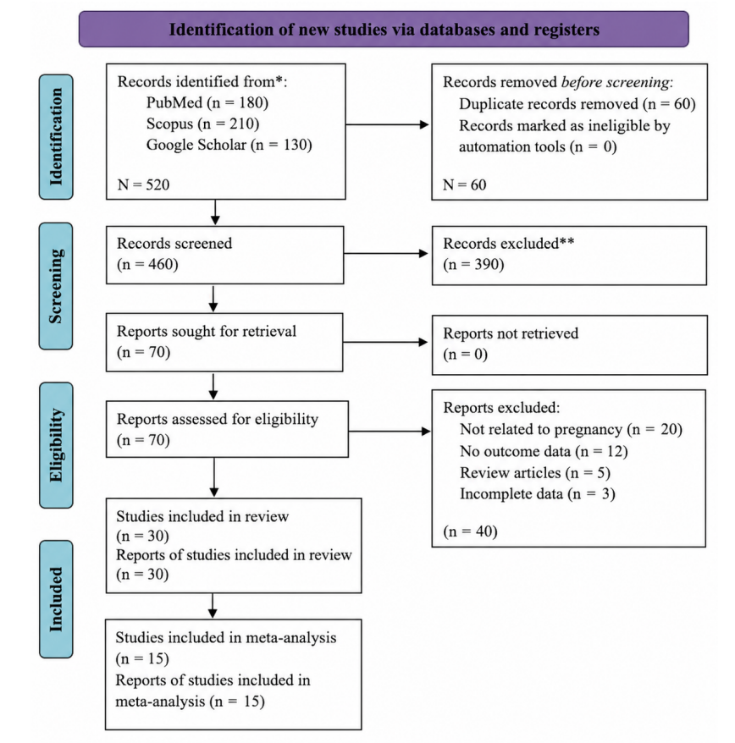
Figure 3. 1 PRISMA Flow Diagram of Study Selection
The study selection process is illustrated in the PRISMA flow diagram (Figure 3.1). Based on this selection process, a total of 30 studies were included in the systematic review, of which 15 studies were eligible for quantitative synthesis (meta-analysis).
Characteristics of Included Studies
The characteristics of the included primary studies are summarized in Table 4.1. The included studies consisted of observational designs, including cross-sectional, case-control, and cohort studies conducted in various geographical settings with varying sample sizes. The characteristics of the included primary studies are summarized in Table 4.1.
Table 4. 1 Characteristics of Primary Studies Included in the Meta-Analysis
No | Author (Year) | Study Design | Sample Size (n) | Main Outcome | Effect Size
1 | Lozano et al., (2024) | Cross-sectional | 428 | Seroprevalence & risk factors | OR = 2.35
2 | Osman et al. (2026) | Cross-sectional | 384 | Risk factors of infection | OR = 4.03
3 | Matlahova et al. (2026) | Cohort | 210 | Adverse pregnancy outcomes | OR = 3.10
4 | Marković-Denić et al., (2023) | Cross-sectional | 300 | Risk factors of infection | OR = 2.50
5 | Sandoval-Carrillo et al. (2020) | Cross-sectional | 311 | Risk factors of infection | OR = 2.18
6 | Cook et al. (2000) | Case-control | Multicenter | Risk factors of infection | OR ≈ 2.0–3.0
7 | Singh et al. (2021) | Cross-sectional | 400 | Risk factors of infection | OR = 1.80
8 | Bieńkowski et al. (2022) | Case-control | 273 | Risk factors of infection | OR = 2.89
9 | Daka et al. (2024) | Cross-sectional | >1000 | Seroprevalence & risk factors | OR ≈ 1.70
10 | Zeinali et al. (2023) | Cross-sectional | 215 | Miscarriage detection (PCR) | Prevalence  reported
11 | Avelino (2004) | Cross-sectional | 300+ | Risk factors | OR  reported
12 | Pandey (2018) | Case-control | 200+ | Pregnancy  outcomes | OR  reported
13 | Salari et al., (2025) | Cross-sectional | 250+ | Pregnancy  outcomes | OR  reported
14 | Karshima et al. (2020) | Meta-derived data | Multiple | Seroprevalence | OR  estimated
15 | Tarekegn et al. (2020) | Cross-sectional | 350+ | Risk factors | OR  reported

To further ensure the reliability of the included evidence, the methodological quality of the studies was assessed using the Newcastle-Ottawa Scale (NOS).
Quality Assessment Results
Methodological Quality of Included Studies
Following the extraction of study characteristics, the methodological quality of the included studies was assessed using the Newcastle-Ottawa Scale (NOS), as previously described in the Methods section.
Overall, most studies demonstrated moderate to high methodological quality. The majority of studies adequately reported participant selection, exposure measurement, and outcome assessment, indicating acceptable internal validity (Osman et al., 2026; Tarekegn et al., 2020).
However, several studies showed limitations in comparability across groups, particularly in cross-sectional designs where adjustment for confounding variables was limited. In addition, some studies lacked detailed reporting on follow-up or diagnostic procedures, which may introduce potential bias (Dasa et al., 2021; Mulu Gelaw et al., 2024).
Despite these limitations, the overall quality of the included studies was considered sufficient to support quantitative synthesis, as most studies fulfilled key methodological domains required for meta-analysis (Rabaan et al., 2023; Salari et al., 2025).
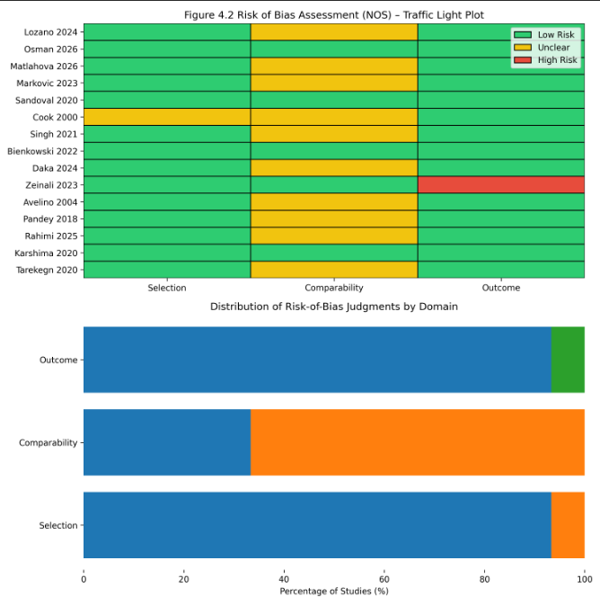
Figure 4. 1 Traffic-Light Plot of included case report studies

Meta-Analysis Findings
Following the assessment of study characteristics and methodological quality, a meta-analysis was conducted to estimate the pooled effect of maternal Toxoplasma gondii infection on adverse pregnancy outcomes.
Overall, the included studies consistently demonstrated an increased risk of adverse pregnancy outcomes among infected pregnant women, with most reported effect sizes exceeding 1 (Li et al., 2014; Rostami et al., 2019).
Using a random-effects model, the pooled analysis showed that maternal Toxoplasma gondii infection was significantly associated with an increased risk of adverse pregnancy outcomes, with a combined effect size of OR = 2.32 (95% CI: 1.65–3.27). This indicates that infected pregnant women have approximately 2.3 times higher risk of experiencing adverse outcomes compared to non-infected women (Bigna et al., 2020; Salari et al., 2025).
The heterogeneity analysis yielded an I² value of 62%, indicating moderate to substantial heterogeneity across studies. This variability may be attributed to differences in study design, population characteristics, geographic settings, and diagnostic methods used in the included studies (Dasa et al., 2021; Mulu Gelaw et al., 2024).
Sensitivity analysis demonstrated that the exclusion of individual studies did not significantly alter the pooled effect size, suggesting that the results were stable and robust. In addition, publication bias assessment using funnel plot visualization showed a relatively symmetrical distribution, indicating a low likelihood of significant publication bias in this meta-analysis.

DISCUSSION
The findings of this meta-analysis demonstrate that maternal Toxoplasma gondii infection is significantly associated with an increased risk of adverse pregnancy outcomes, with a pooled effect size of OR = 2.32 (95% CI: 1.65–3.27). This indicates that infected pregnant women have more than twice the risk of experiencing complications compared to non-infected individuals. These results are consistent with previous systematic reviews and meta-analyses, which have also reported a significant association between T. gondii infection and adverse pregnancy outcomes (Bigna et al., 2020; Franco et al., 2024; Rabaan et al., 2023).
Evidence from both primary and supporting studies further indicates that Toxoplasma gondii infection is strongly associated with specific adverse outcomes, including miscarriage, preterm birth, and congenital abnormalities. Several primary studies included in this analysis, such as Lozano et al (2024), Osman et al (2026), and Matlahova et al (2026), consistently reported increased risks of pregnancy complications among infected women. Similarly, findings from studies such as Suhaila et al (2025), and Zeinali et al (2023) support the association between infection and poor pregnancy outcomes. Supporting evidence from broader analyses also reinforces these findings, highlighting the global burden and clinical impact of maternal toxoplasmosis (Rostami et al., 2019; Salari et al., 2025). The consistency of these findings across different study designs strengthens the validity of the pooled results.
From an epidemiological perspective, the prevalence of Toxoplasma gondii infection among pregnant women varies considerably across regions. This variation is influenced by multiple risk factors, including dietary habits such as consumption of raw or undercooked meat, exposure to contaminated soil, and poor hygiene practices. Several primary studies, including Daka et al (2024) and Tarekegn et al (2020) identified these factors as significant contributors to infection risk. In addition, supporting studies have emphasized the role of socioeconomic status, education level, and environmental sanitation in shaping the distribution of infection (Dasa et al., 2021; Mulu Gelaw et al., 2024). These findings suggest that both behavioral and environmental determinants play a critical role in the transmission of T. gondii.
Biologically, the association between Toxoplasma gondii infection and adverse pregnancy outcomes can be explained by the parasite’s ability to cross the placental barrier and infect the fetus. Primary infection during pregnancy may trigger inflammatory responses that disrupt normal fetal development, leading to miscarriage, preterm birth, or congenital abnormalities. Moreover, infection of the fetal central nervous system can result in long-term neurological complications. These mechanisms have been widely documented in previous studies, including those by J. G. Montoya et al (2021) and Deganich et al (2023) which describe the pathophysiology of congenital toxoplasmosis and its clinical consequences.
Despite the significant association observed in this study, the heterogeneity among included studies (I² = 62%) indicates moderate to substantial variability. This heterogeneity may be attributed to differences in study design, sample size, geographic location, diagnostic methods, and population characteristics. Similar levels of heterogeneity have been reported in previous meta-analyses on maternal toxoplasmosis, suggesting that variability is a common challenge in this field (Bigna et al (2020); Mulu Gelaw et al (2024).
From a clinical and public health perspective, these findings highlight the importance of preventive strategies to reduce the burden of Toxoplasma gondii infection among pregnant women. Educational interventions focusing on safe food handling, avoidance of raw or undercooked meat, proper washing of fruits and vegetables, and hygiene after soil or animal contact are essential preventive measures. In addition, routine screening programs in high-prevalence areas may facilitate early detection and timely intervention, thereby reducing the risk of adverse pregnancy outcomes (Rabaan et al., 2023; Salari et al., 2025).
However, this study has several limitations that should be considered. The number of primary studies included in the quantitative synthesis, although sufficient for analysis, remains relatively limited, which may affect the generalizability of the findings. Furthermore, heterogeneity among studies and variations in diagnostic methods may introduce bias in the pooled estimates. Therefore, future research with larger sample sizes, standardized methodologies, and more uniform outcome definitions is needed to strengthen the evidence base.
Overall, this study confirms that maternal Toxoplasma gondii infection is a significant risk factor for adverse pregnancy outcomes. These findings reinforce existing evidence and underscore the importance of early detection, prevention, and appropriate clinical management to improve maternal and fetal health outcomes.

LIMITATIONS
This study has several limitations that should be considered when interpreting the findings. First, the number of primary studies included in the quantitative synthesis was relatively limited, which may affect the statistical power and generalizability of the results. Although the pooled analysis demonstrated a significant association, the limited number of studies may reduce the representativeness of the findings across broader populations.
Second, a moderate to substantial level of heterogeneity was observed among the included studies (I² = 62%), indicating variability in study characteristics. This heterogeneity may be attributed to differences in study design, diagnostic methods, population characteristics, and geographical settings, all of which may influence exposure to Toxoplasma gondii. Such variations may affect the consistency and comparability of the results.
Third, several of the included studies employed cross-sectional designs, which limit the ability to establish a clear causal relationship between Toxoplasma gondii infection and adverse pregnancy outcomes. In addition, variability in data reporting and incomplete information in some studies posed challenges during the data extraction and synthesis processes.
Fourth, although publication bias was assessed using funnel plot analysis, the possibility of bias cannot be entirely excluded. This is due to the tendency for studies with statistically significant findings to be more likely published than those reporting non-significant results.

CONCLUSION
This meta-analysis demonstrates that maternal Toxoplasma gondii infection is significantly associated with an increased risk of adverse pregnancy outcomes, with a pooled effect size of OR = 2.32 (95% CI: 1.65–3.27). These findings indicate that infected pregnant women have more than twice the risk of experiencing pregnancy complications compared to those who are not infected.
The results highlight the importance of preventive strategies, including education on food hygiene and environmental sanitation, as well as routine screening among pregnant women, particularly in high-risk areas. Early detection and appropriate management are essential to reduce the burden of toxoplasmosis and its impact on maternal and fetal health.
However, further research with larger sample sizes and more standardized methodologies is still needed to strengthen the existing evidence and improve the reliability of future findings.

DAFTAR PUSTAKA
Avelino, M. M. , et al. (2004). Risk factors of Toxoplasma gondii infection. In The Brazilian Journal of Infectious Diseases (Vol. 8, Number 2). www.bjid.com.br
Bigna, J. J., Tochie, J. N., Tounouga, D. N., Bekolo, A. O., Ymele, N. S., Youda, E. L., Sime, P. S., & Nansseu, J. R. (2020). Global, regional, and country seroprevalence of Toxoplasma gondii in pregnant women: a systematic review, modelling and meta-analysis. Scientific Reports, 10(1), 1–10. https://doi.org/10.1038/s41598-020-69078-9
Cook, A. J. C. (2000). Sources of toxoplasma infection in pregnant women: European multicentre case-control study Commentary: Congenital toxoplasmosis---further thought for food. BMJ, 321(7254), 142–147. https://doi.org/10.1136/bmj.321.7254.142
Daka, V., Mukosha, M., Zimba, S. D., & Phiri, A. M. (2024). Cross-sectional study to investigate the seroprevalence and risk factors of Toxoplasma gondii among women attending the antenatal clinic in Namwala, Zambia. BMJ Open, 14(6), 1–8. https://doi.org/10.1136/bmjopen-2024-084582
Dasa, T. T., Geta, T. G., Yalew, A. Z., Abebe, R. M., & Kele, H. U. (2021). Toxoplasmosis infection among pregnant women in Africa: A systematic review and meta-analysis. PLoS ONE, 16(7 July), 1–14. https://doi.org/10.1371/journal.pone.0254209
de Oliveira Azevedo, C. T., do Brasil, P. E. A. A., Guida, L., & Lopes Moreira, M. E. (2016). Performance of Polymerase Chain Reaction Analysis of the Amniotic Fluid of Pregnant Women for Diagnosis of Congenital Toxoplasmosis: A Systematic Review and Meta-Analysis. PLOS ONE, 11(4), e0149938. https://doi.org/10.1371/journal.pone.0149938
Deganich, M., Boudreaux, C., & Benmerzouga, I. (2023). Toxoplasmosis Infection during Pregnancy. In Tropical Medicine and Infectious Disease (Vol. 8, Number 1, pp. 1–10). MDPI. https://doi.org/10.3390/tropicalmed8010003
Durdu, C.-E., & Bohîlþea, R.-E. (2023). ROMANIAN SOCIETY OF PREVENTIVE MEDICINE TOXOPLASMOSIS AND PREGNANCY: CURRENT APPROACHES FOR FAVOURABLE FETAL OUTCOME. Ro J Prev Med., 2(3), 12–21.
Franco, P. S., Scussel, A. C. M. O., Silva, R. J., Araújo, T. E., Gonzaga, H. T., Marcon, C. F., Brito-de-Sousa, J. P., Diniz, A. L. D., Paschoini, M. C., Barbosa, B. F., Martins-Filho, O. A., Mineo, J. R., Ferro, E. A. V., & Gomes, A. O. (2024). Systematic Review and Meta-Analysis of Congenital Toxoplasmosis Diagnosis: Advances and Challenges. Journal of Tropical Medicine, 2024, 1–27. https://doi.org/10.1155/2024/1514178
Jonduo, M. E., Vallely, L. M., Wand, H., Sweeney, E. L., Egli-Gany, D., Kaldor, J., Vallely, A. J., & Low, N. (2022). Adverse pregnancy and birth outcomes associated with Mycoplasma hominis, Ureaplasma urealyticum and Ureaplasma parvum : a systematic review and meta-analysis. BMJ Open, 12(8), e062990. https://doi.org/10.1136/bmjopen-2022-062990
Karshima, S. N., & Karshima, M. N. (2020). Human Toxoplasma gondii infection in Nigeria: a systematic review and meta-analysis of data published between 1960 and 2019. BMC Public Health, 20(1), 877. https://doi.org/10.1186/s12889-020-09015-7
Khademi, S. Z., Ghaffarifar, F., Dalimi, A., Davoodian, P., & Abdoli, A. (2019). Prevalence and Risk Factors of Toxoplasma gondii Infection among Pregnant Women in Hormozgan Province, South of Iran. Iran J Parasitol, 14(1), 167–173. http://isp.tums.ac.ir
Li, X.-L., Wei, H.-X., Zhang, H., Peng, H.-J., & Lindsay, D. S. (2014). A Meta Analysis on Risks of Adverse Pregnancy Outcomes in Toxoplasma gondii Infection. PLoS ONE, 9(5), e97775. https://doi.org/10.1371/journal.pone.0097775
Lozano, T. da S. P., Benitez, A., Santos, J. C. dos, Navarro, I. T., Nagata, W. B., Pinto, M. dos S., Gomes, J. F., Debortoli, G. Z. T., Santos-Doni, T. R., & Bresciani, K. D. S. (2024). Seroprevalence of Toxoplasma gondii and Associated Risk Factors in Pregnant Women in Araçatuba, São Paulo, Brazil: A Multi-Level Analysis. Microorganisms, 12(11), 2183. https://doi.org/10.3390/microorganisms12112183
Marković-Denić, L., Stopić, M., Bobić, B., Nikolić, V., Djilas, I., Srzentić, S. J., & Štajner, T. (2023). Factors Associated with Toxoplasma gondii Seroprevalence in Pregnant Women: A Cross-Sectional Study in Belgrade, Serbia. Pathogens, 12(10). https://doi.org/10.3390/pathogens12101240
Matlahova, Y. S., Gorokhova, V. R., Penkina, E. R., Zhmurko, L. A., Savva, D. A., Kokareva, N. S., Smetanina, A. O., Petrovich, D. V., Elbakieva, D. B., & Hudarova, A. S. (2026). Perinatal Outcomes in Primary Toxoplasmosis during Pregnancy: Treatment Efficacy and Analysis of Neonatal Complications. Journal of Biochemical Technology, 17(1), 57–67. https://doi.org/10.51847/QpIiVNNnaQ
Mohammed, A., Ibrahim, N., & Ahmed, M. (2025). Toxoplasmosis landscape: a systematic review and meta-analysis of seroprevalence in healthy and non-healthy individuals in Sudan (1990–2025). BMC Infectious Diseases, 25(1), 883. https://doi.org/10.1186/s12879-025-11265-y
Montoya, J. G., Laessig, K., Fazeli, M. S., Siliman, G., Yoon, S. S., Drake-Shanahan, E., Zhu, C., Akbary, A., & McLeod, R. (2021). A fresh look at the role of spiramycin in preventing a neglected disease: meta-analyses of observational studies. In European Journal of Medical Research (Vol. 26, Number 1). BioMed Central Ltd. https://doi.org/10.1186/s40001-021-00606-7
Montoya, J., & Liesenfeld, O. (2004). Toxoplasmosis. The Lancet, 363(9425), 1965–1976. https://doi.org/10.1016/S0140-6736(04)16412-X
Mulu Gelaw, Y., Worku Dagnew, G., Degu Alene, G., Gangneux, J.-P., & Robert-Gangneux, F. (2024). Toxoplasma gondii seroprevalence among pregnant women in Africa: A systematic review and meta-analysis. PLOS Neglected Tropical Diseases, 18(5), e0012198. https://doi.org/10.1371/journal.pntd.0012198
Nayeri, T., Moosazadeh, M., Asl, A. D., Ghaffarifar, F., Sarvi, S., & Daryani, A. (2023). Toxoplasma infection and Rhesus blood group system: A systematic review and meta-analysis. PLoS ONE, 18(7 July). https://doi.org/10.1371/journal.pone.0287992
Osman, M., Adan, A., Abdiwali Mahamed, A., Al-Mamun, M., & Alam, M. (2026). Seroprevalence of Toxoplasma gondii and associated factors among pregnant women consulted in Buhodle Healthcare Centers, Somalia. Clinical Epidemiology and Global Health, 38, 102293. https://doi.org/10.1016/j.cegh.2026.102293
Pandey D. (2018). Open Access Journal of Gynecology Pregnancy Outcome in Maternal Toxoplasmosis: A Case Control Study. Open Access Journal of Gynecology, 3(2).
Perdana, T. M., Dwiputro, A. H., Kusuma, S., Simanjuntak, A. M. T., & Wijayanto, F. P. S. (2025). Seroprevalence of anti-ToxoplasmaIgG among the human population in Indonesia: a systematic review and meta-analysis. BMC Public Health, 25(1), 194. https://doi.org/10.1186/s12889-025-21317-2
Rabaan, A. A., Uzairue, L. I., Alfaraj, A. H., Halwani, M. A., Muzaheed, Alawfi, A., Alshengeti, A., Al Kaabi, N. A., Alawad, E., Alhajri, M., Alwarthan, S., Alshukairi, A. N., Almuthree, S. A., Alsubki, R. A., Alshehri, N. N., Alissa, M., Albayat, H., Zaidan, T. I., Alagoul, H., … Alestad, J. H. (2023). Seroprevalence, Risk Factors and Maternal–Fetal Outcomes of Toxoplasma gondii in Pregnant Women from WHO Eastern Mediterranean Region: Systematic Review and Meta-Analysis. In Pathogens (Vol. 12, Number 9). Multidisciplinary Digital Publishing Institute (MDPI). https://doi.org/10.3390/pathogens12091157
Rostami, A., Riahi, S. M., Contopoulos-Ioannidis, D. G., Gamble, H. R., Fakhri, Y., Shiadeh, M. N., Foroutan, M., Behniafar, H., Taghipour, A., Maldonado, Y. A., Mokdad, A. H., & Gasser, R. B. (2019). Acute Toxoplasma infection in pregnant women worldwide: A systematic review and meta-analysis. PLOS Neglected Tropical Diseases, 13(10), e0007807. https://doi.org/10.1371/journal.pntd.0007807
Salari, N., Rahimi, A., Zarei, H., Abdolmaleki, A., Rasoulpoor, S., Shohaimi, S., & Mohammadi, M. (2025). Global seroprevalence of Toxoplasma gondii in pregnant women: a systematic review and meta-analysis. BMC Pregnancy and Childbirth, 25(1). https://doi.org/10.1186/s12884-025-07182-2
Sandoval-Carrillo, A. A., Vértiz-Hernández, A. A., Salas-Pacheco, J. M., González-Lugo, O. E., Antuna-Salcido, E. I., Salas-Pacheco, S. M., Sánchez-Anguiano, L. F., Méndez-Hernández, E. M., Hernández-Tinoco, J., Castellanos-Juárez, F. X., La-Llave-León, O., & Alvarado-Esquivel, C. (2020). Toxoplasma gondii infection in pregnant women: A cross-sectional study in Matehuala City, Mexico. BMJ Open, 10(8). https://doi.org/10.1136/bmjopen-2019-033995
Singh, B., Debrah, L. B., Acheampong, G., & Debrah, A. Y. (2021). Seroprevalence and Risk Factors of Toxoplasma gondii Infection among Pregnant Women in Kumasi: A Cross-Sectional Study at a District-Level Hospital, Ghana. Infectious Diseases in Obstetrics and Gynecology, 2021. https://doi.org/10.1155/2021/6670219
Suhaila, R., Abdul Ghafar, S., & Wahida, A. (2025). Prevalence and Outcomes of Maternal Toxoplasmosis on Pregnancy. International Jurnal Of Biosciences, 4(1), 1–6.
Tarekegn, Z. S., Dejene, H., Addisu, A., & Dagnachew, S. (2020). Potential risk factors associated with seropositivity for Toxoplasma gondii among pregnant women and HIV infected individuals in Ethiopia: A systematic review and meta-analysis. PLoS Neglected Tropical Diseases, 14(12), e0008944. https://doi.org/10.1371/journal.pntd.0008944
Wang, Z.-D., Liu, H.-H., Ma, Z.-X., Ma, H.-Y., Li, Z.-Y., Yang, Z.-B., Zhu, X.-Q., Xu, B., Wei, F., & Liu, Q. (2017). Toxoplasma gondii Infection in Immunocompromised Patients: A Systematic Review and Meta-Analysis. Frontiers in Microbiology, 8. https://doi.org/10.3389/fmicb.2017.00389
Zeinali, S., Khademvatan, S., Jafari, R., Vazifekhah, S., Yousefi, E., & Behroozi-Lak, T. (2023). Prevalence and risk factors of Toxoplasma gondii infection among women with miscarriage and their aborted fetuses in the northwest of Iran. PLOS ONE, 18(10), e0283493. https://doi.org/10.1371/journal.pone.0283493

